**MEWS-Kickoff agenda (updated 7.6.2024)**

Sunday 16 June - arrival in Leipzig

Monday 17 June,

Zoom 9:00 – 17:00: <https://ufz-de.zoom-x.de/meeting/u5csdeytrDotGtPILrNexzvrfnJPSrGprE-y/ics?icsToken=98tyKu-rrzkvH9aUtxmAR_MqBYjoZ-_zpn5ajbdttTP3LSVLeBXkMOxoAoFtN8jC>

|  |  |  |
| --- | --- | --- |
| **Time** | **Location** | **Activity** |
| 9:00 – 9:10 | UFZ campus, building 1.0, Room 220 (1st floor) | Welcome and agenda |
| 9:10_9:40 | Progress so far Sweden |
| 9:40 – 10:10 | Progress so far Germany |
| 10:10 – 10:40 | Progress so far Israel |
| 10:40 – 12:30 | Discussion of stakeholder interactions- planning for Wednesday |
| 12:30 - 13:30 | UFZ canteen | Lunch |
| 13:30 - 17:00 | UFZ campus, building 1.0, Room 220 | Modelling block 1 |
| evening | Downtown Leipzig | Dinner/drinks |

Tuesday 18 June

Zoom 9:00 – 17:00: https://ufz-de.zoom-x.de/meeting/u5csdeytrDotGtPILrNexzvrfnJPSrGprE-y/ics?icsToken=98tyKu-rrzkvH9aUtxmAR_MqBYjoZ-_zpn5ajbdttTP3LSVLeBXkMOxoAoFtN8jC

|  |  |  |
| --- | --- | --- |
| **Time** | **Location** | **Activity** |
| 9:00 – 9:30 | UFZ, bldg 2.0, Blue Salon (1st floor) | Project planning – Review of deliverables |
| 9:00 - 12:30 | Modelling block 2  Zoom: |
| 12:30 - 13:30 | UFZ canteen | Lunch |
| 13:30 - -17:00 | UFZ, bldg 2.0, Blue Salon | Modelling block 3 |
| 19:00 | Ratskeller,  Lotterstrasse 1, 04109 Leipzig (downtown) | MEWS dinner |

Wednesday 19 June

|  |  |  |
| --- | --- | --- |
| **Time** | **Location** | **Activity** |
| 07:50 meet 8:00 depart | UFZ-Leipzig Meet outside “KUBUS” | Depart from UFZ Leipzig and drive to [Ohra reservoir](https://maps.app.goo.gl/U2wdVbyYR1iPWXUi6) in Thuringia |
| 10:30 - 12:30 | Water Works Ohra reservoir, Friedrich-Engels-Str 84, 99885 Luisental | Meet with stakeholders locally + live transmission  Zoom: https://ufz-de.zoom-x.de/j/5215006662?omn=64250235578 |
| 12:30 - 13:30 |  | Lunch, potentially picnic at nice place on the reservoir, or local restaurant at Luisental |
| 13:30 - 15:30 | Ohra reservoir | Walk through forest along the reservoir shore |
| 16:00 - 18:00 |  | Return to Leipzig |
| evening | Leipzig | Dinner/drinks |

Thursday 20 June

Zoom 9:00 – 17:00: https://ufz-de.zoom-x.de/meeting/u5csdeytrDotGtPILrNexzvrfnJPSrGprE-y/ics?icsToken=98tyKu-rrzkvH9aUtxmAR_MqBYjoZ-_zpn5ajbdttTP3LSVLeBXkMOxoAoFtN8jC

|  |  |  |
| --- | --- | --- |
| **Time** | **Location** | **Activity** |
| 9:00 - 12:30 | UFZ, bldg 2.0, Blue Salon (1st floor) | Planning block. goals for the next year (timetable, milestones, deliverables, …) |
| 12:30 - 13:30 | UFZ canteen | Lunch |
| 13:30 - -16:00 | UFZ, bldg 2.0, Blue Salon | Modelling block 4, or planning block 2 |

Friday 21 June departure

**Note** that there will be 2 European Cup soccer matches in Leipzig during our meeting: Portugal v. Czech Republic on 18.6, and Netherlands v. France on 21.6.

**Locations**UFZ campus

Helmholtz Centre for Environmental Research - UFZ  
Permoser Strasse 15,  
04318 Leipzig, Germany  
UFZ Leipzig: <https://maps.app.goo.gl/LQHjp2y93tjraN4S8>

The UFZ campus is easily reachable from downtown Leipzig, which is the area to the south west of central station. From downtown it's a 15 minute tram ride (line 3) to the campus, get off at stop Permoser/Torgauerstrasse.

On Wednesday 19.6 we will drive (~2 hr) to the Ohra Reservoir (<https://maps.app.goo.gl/oznenpqE4FiG9RHm7>) and back on the same day.

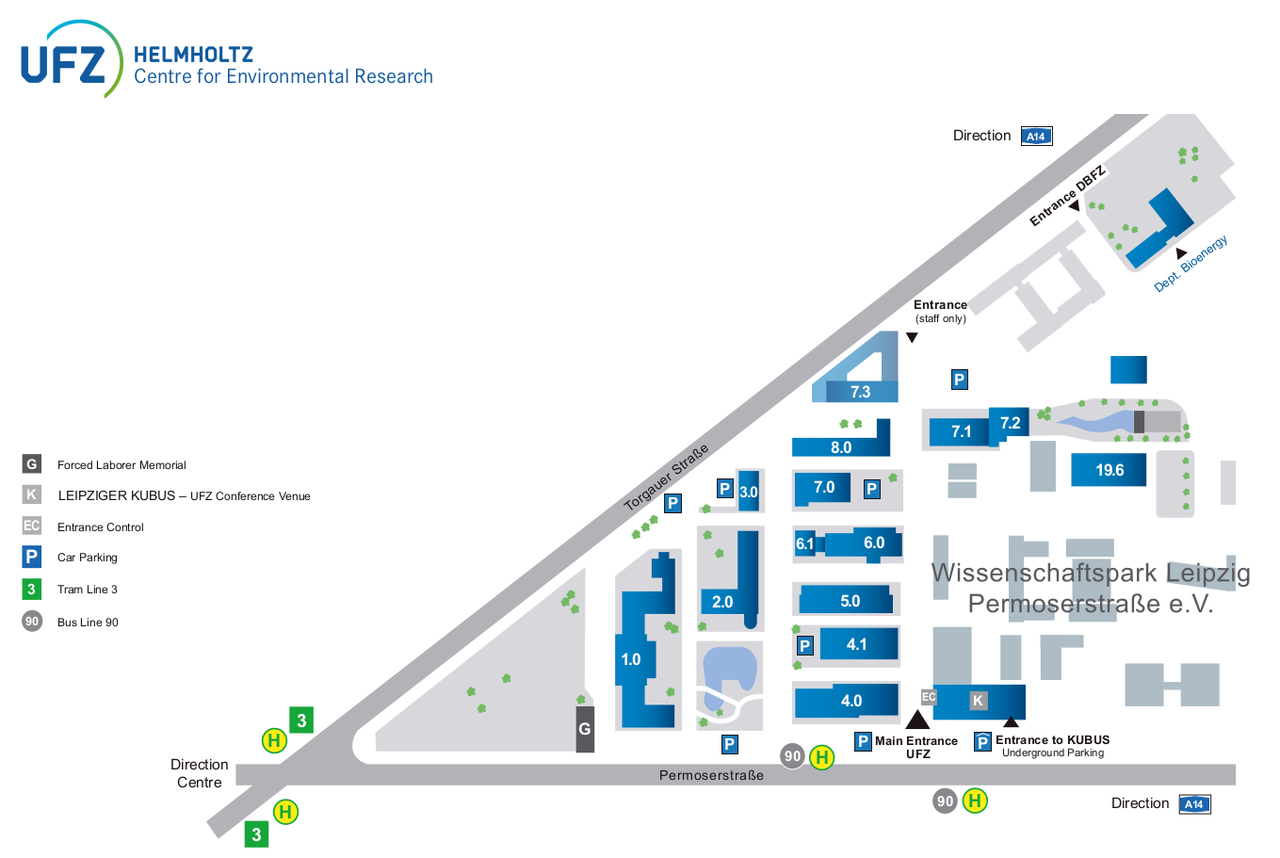

Tram line 3

Stop: Permoser/Torgauerstrasse

Building 1.0

Room 220

Building 2.0

Blue Salon & Canteen

Direction Leipzig central